Assessment # Student: _____________________
______________________/10
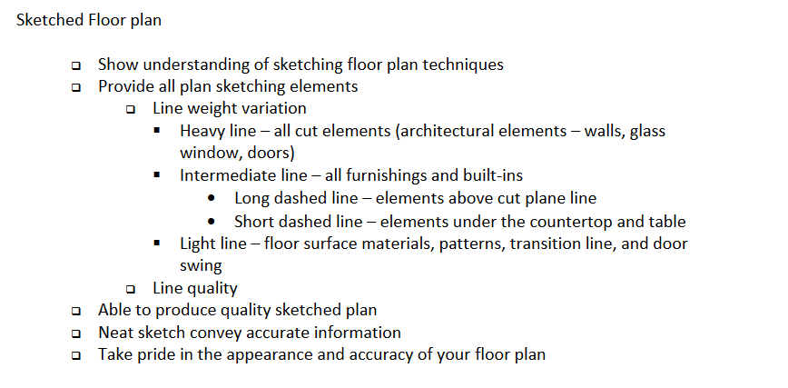

Assessment # Student: _____________________
______________________/10

