Assessment – Elevation Student: __________________

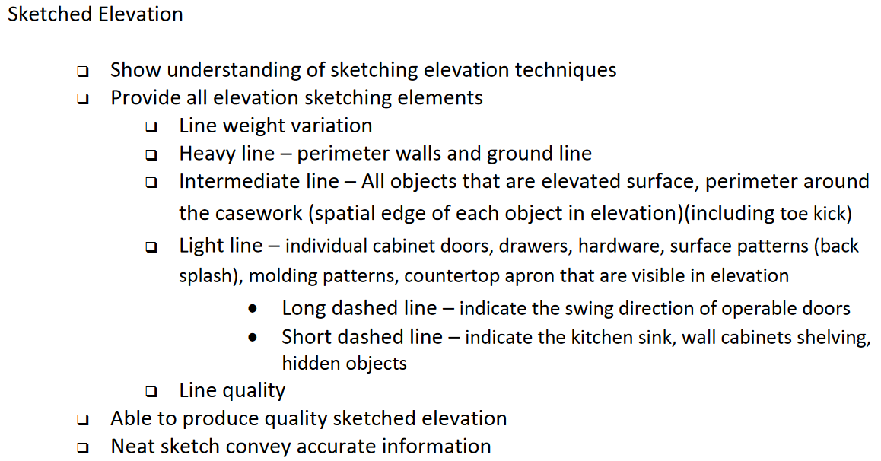

Total: __________________/10

