5th set of Sketches score sheet Student: _________________

Perspective – Sketch living room and foyer using photographs
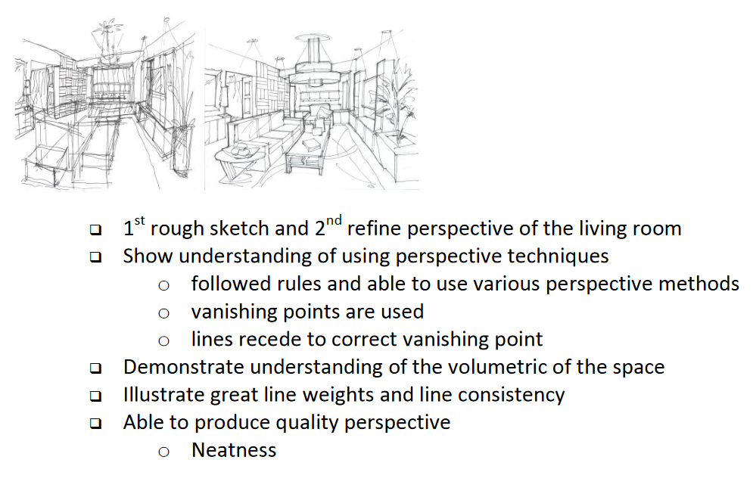

Total: ______________/20

